**VIRAL**

**INFECTION**

**Created by: Kieran Boyce, Ryan Manning, Harry Statham and Liam David**



**Viral Infection**

Playtime: 30mins - 2 hours

**Setting Up The Game**

The first thing to do is to sort out all of the player cards into 4 piles and have all the virus cards in a pile as well. Next is to split the board pieces so that everyone has four.

Once that is done the players need to take turns in building the board together first of all the youngest player will place a piece down and then the next youngest player will place a piece down and this will keep rotating the turns until the board is complete.

Each of the players will place their base pieces in each corner of the board and the virus begins in the middle of the board and will have 3 cards flipped over at the beginning of the game. For the remainder of the game the virus will have 2 cards flipped over after every turn.

**The Goal**

The goal for this game is to vaccinate the entire board.

Or the virus is gone and the players roll the same colour ⅔ times.

**Loss Conditions**

* Player runs out of cards
* Virus has 12 pieces on the board at one time

**What the pieces do**

* Player pieces - indicates where the player is.
* Virus pieces - indicates where the virus is.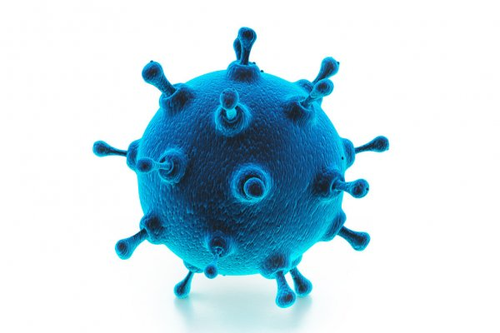
* Player cards - These cards will determine what the player is able to do on their turn.
* Virus cards - These cards will determine what the virus can do on its turn.
* Wall - a wall will block off an area for the virus so it won't be able to progress. This lasts for one round
* Research pieces - grant the player vaccine cards
* Vaccine cards - vaccinate board piece (all viruses are on it are killed and can't respawn there)
* Energy token - these are the cost of turns i.e some cards will require 1 energy etc.
* Coloured Die - used for deciding things such as movement direction etc.
* Base piece - player movement starts from here

**Rules**

Basic playthrough -

* The virus will begin the game and will have 3 cards flipped over, this is only for the first turn however and the virus will then follow the actions on those cards.
* Next is the turn of the player and they will draw 6 cards and use energy points(players get three energy per turn) for each move they decide to use on their cards in their hand.
* If the player gets a research token from a card they can receive vaccine cards which can vaccinate a board piece making it immune.
* The player is also able to end their turn at any time.
* The player can also discard a card if they give up one of their energy.
* When the round is complete and every player has had their turn the virus will then draw 2 cards and act on those like they did in the first turn (however if turn count for the virus can increase depending on the cards drawn)
* When the virus has all of its pieces destroyed the player then needs to roll the dice to a certain colour ⅔ times to be victorious, if not then the virus will respawn on a non vaccinated board piece.
* Once all the board is vaccinated the players win and the game is over
* If the players take too long and the players run out of cards then the game ends and the virus is the winner.

